**Colonel James T. McGovern**

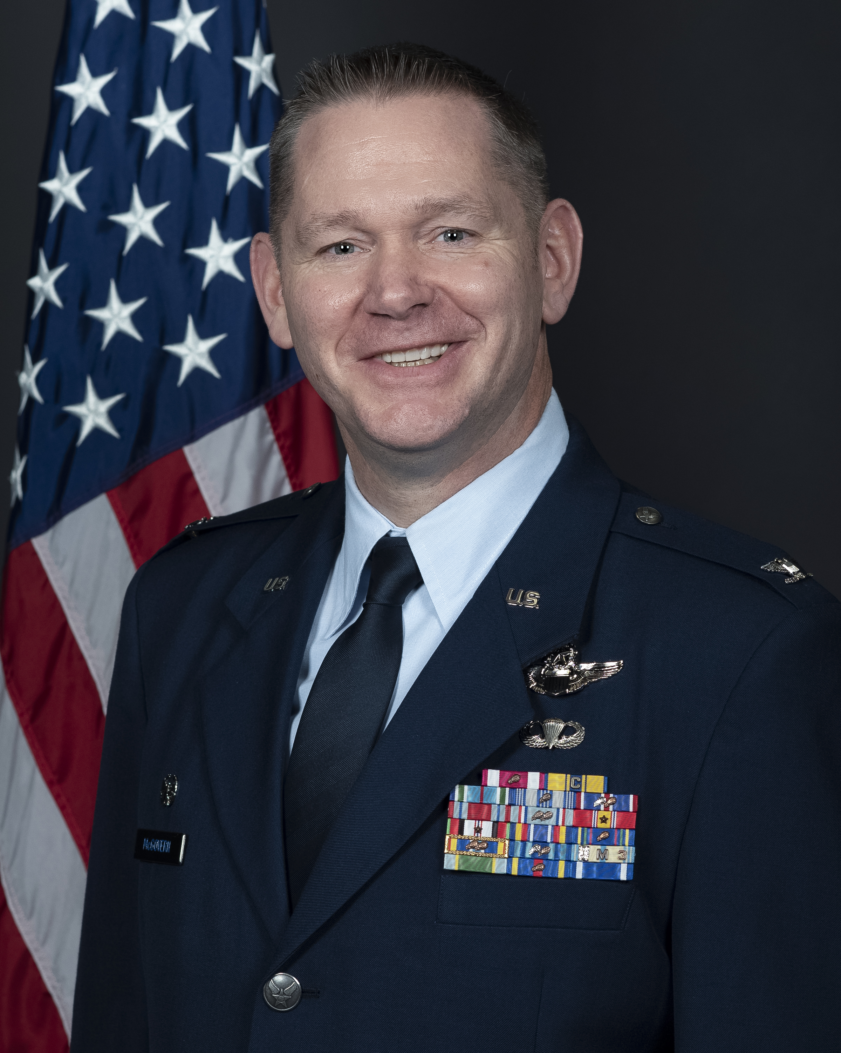

Colonel James T. McGovern is the Commander of the 141st Air Refueling Wing, Washington Air National Guard located at Fairchild Air Force Base, Washington. The 141st Air Refueling Wing has both a Federal and State mission and is Classically Associated with the 92d Air Refueling Wing sharing 63 KC-135 aircraft valued at $3.5 billion. When gained by Air Mobility Command, the federal mission is to train, equip, and deploy quality mobility forces to forward operating locations in support of specific contingency plans and other short notice taskings. Under order of the Governor of the State of Washington, the wing provides protection of life and property while preserving peace, order, and public safety

# Col. McGovern began his career as an enlisted member of the United States Air Force in 1995. He was selected from 500 candidates to participate in the Survival Evasion Resistance and Escape Instructor Technical School. He was one of twelve graduates and completed training as the Distinguished Graduate and Cadre Award winner in December 1995. Col. McGovern served for four years as a SERE Specialist. During his time as a SERE Specialist, he taught over 800 Aircrew members, accumulated over 40 parachutes jumps, and earned his Bachelor Degree from Park University. He joined the Washington Air National Guard in January 1999, and served as a drill status guardsman Life Support Technician until he earned his commission from the Air National Guard’s Academy of Military Science in 2001. He completed undergraduate pilot training at Columbus AFB, Miss., in May 2002 and returned to the 116th Air Refueling Squadron, Fairchild AFB. Col. McGovern served as a drill status pilot from October 2002 until January 2011 while working full-time for the USAF SERE School. He began his full-time National Guard service in January 2011 and served as Evaluator Pilot, Instructor Pilot, Pilot Scheduler, Chief of Scheduling/Current Operations, and Chief of Special Plans. Col. McGovern was a by-name selection of U.S. Pacific Command Senior Enlisted Advisor and the J358 Chief to stand up the Joint Personnel Recovery Center and earned the Joint Service Achievement medal for his efforts from January – September 2015 while serving at Camp H.M. Smith, Hawaii. He assumed the position as the Chief of Wing Plans in October 2015 upon his return to the 141st and served in this position until assuming Command of the Operations Support Squadron in March 2017- June 2020. Most recently Col. McGovern served as commander of the 141st Maintenance Group.

**EDUCATION**

1998 Associate Degree, Survival, Search and Rescue, Community College of the Air Force

1998 Associate Degree, Instructor of Technology and Military Science, Community College of the Air Force

1998 Bachelor of Science, Business Administration Management, Park University, Parkville, Mo

2010 Squadron Officer School, Maxwell Air Force Base, Ala., by correspondence  
2016 Air Command and Staff College, Maxwell AFB, Ala., by correspondence

2021 Air War College, Maxwell AFB, Ala., by correspondence

**ASSIGNMENTS**

1. January 1995–March 1995, Student, Basic Military Training, Lackland Air Force Base, Texas

2. March 1995–April 1995, Student, SERE Instructor Indoctrination Course, Lackland AFB, Texas

3. June 1995–December 1995, Student, SERE Instructor Technical School, Fairchild AFB, Wash

4. January 1996–January 1998, SERE Specialist, Field Training, 22nd Training Squadron, Fairchild AFB, Wash

5. February 1998–January 1999, SERE Specialist, Parachuting, 22nd Training Squadron, Fairchild AFB, Wash

6. January 1999–January 2001, Life Support Technician, 116th Air Refueling Squadron, Fairchild AFB, Wash

7. January 2001–February 2001, Student, Academy of Military Science, McGhee-Tyson ANGB, Tenn

**ASSIGNMENTS (Cont.)**

8. April 2001 –May 2002, Student, Undergraduate Pilot Training, Columbus AFB, Miss

9. June 2002–October 2002, Student, KC-135 Combat Crew Training School, Altus AFB, Okla

10. October 2002–November 2005, KC-135 Co-Pilot, 116th Air Refueling Squadron, Fairchild AFB, Wash

11. November 2005–May 2012, KC-135 Aircraft Commander, 116th Air Refueling Squadron, Fairchild AFB, Wash

12. May 2012–Present, KC-135 Instructor Pilot, 116th Air Refueling Squadron, Fairchild AFB, Wash

13. January 2011–April 2013, Chief of Scheduling/Current Operations, 141st Operations Group, Fairchild AFB, Wash

14. April 2013–January 2105, Chief of Special Plans, 141st Air Refueling Wing, Fairchild AFB, Wash

15. January 2015–September 2015, Deputy Director USPACOM Joint Personnel Recovery Center, Camp H.M. Smith, Hawaii

16. October 2015–March 2017, Chief of Wing Plans, 141st Air Refueling Wing, Fairchild AFB, Wash.

17. March 2017–June 2020, Commander, 141st Operations Support Squadron, Fairchild AFB, Wash.

18. June 2020 – January 2021, Commander, 141st Maintenance Squadron, Fairchild AFB, Wash.

19. January 2021 – January 2023, Commander, 141st Maintenance Group Commander, Fairchild AFB, Wash.

20. January 2023 – Present, Commander, 141st Air Refueling Wing, Fairchild AFB, Wash.

**FLIGHT INFORMATION**

Rating: Command Pilot  
Flight hours: More than 2,000  
Aircraft flown: T-37, T-1, KC-135

**MAJOR AWARDS AND DECORATIONS**

#### Air Force Meritorious Service Medal with oak leaf cluster

#### Air Force Commendation Medal with oak leaf cluster and “C” Device

#### Joint Service Achievement Medal Air Force Achievement Medal with oak leaf cluster

#### Air Force Outstanding Unit Award with three oak leaf clusters

#### Combat Readiness Medal

#### Air Force Good Conduct Medal with oak leaf cluster

#### National Defense Service Medal with bronze star

#### Global War on Terrorism Service Medal

#### Air Force Expeditionary Service Ribbon with Gold Border

#### Air Force Longevity Service Ribbon with three oak leaf clusters

#### Armed Forces Reserve Medal with two “M” Devices

#### Small Arms Expert Marksmanship Ribbon

#### Air Force Training Ribbon

**EFFECTIVE DATES OF PROMOTION**

Second Lieutenant February 16, 2001

First Lieutenant February 16, 2003

Captain February 16, 2005

Major July, 1 2011

Lieutenant Colonel October 14, 2017

Colonel November 30, 2022

(Current as of December 2022)