|  |  |  |  |
| --- | --- | --- | --- |
| |  |  |  | | --- | --- | --- | | Seal | Biography | Flag | |
| ***U N I T E D   S T A T E S   A I R   F O R C E*** |

**COLONEL ANGELA M. O’CONNELL**

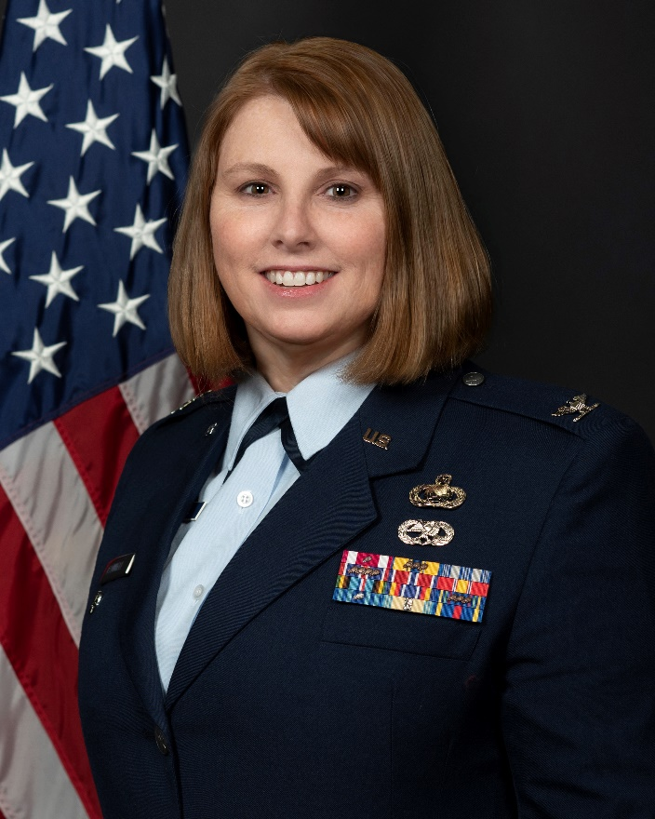Colonel Angela M. O’Connell serves as the Vice Commander of the 141st Air Refueling Wing, Fairchild Air Force Base, Washington. She assists the commander in directing and coordinating headquarters staff activities to assure the worldwide mission readiness of 1,000 Air National Guardsmen assigned to Fairchild Air Force Base, Wash. She establishes policies for the unit administration, operations, training, maintenance and supply.

Col. O’Connell received her commission in the United States Air Force in August 1996 from the Reserve Officer Training Corps at The Ohio State University. She completed the Aircraft Maintenance Officer Course in 1997 at Sheppard Air Force Base, Texas and was initially assigned to the 92d Aircraft Generation Squadron at Fairchild Air Force Base, Washington. In 1999, she cross-trained into Public Affairs and attended the Public Affairs Officer Course at Fort Meade, Maryland. She served as the Chief of Public Affairs at Laughlin Air Force Base, Texas. In 2000, she left the Active Duty and joined the Air Force Reserve where she served as an Executive Officer and Public Affairs Officer at the Wing, Numbered Air Force and Major Command levels. Finally, she joined the Washington Air National Guard in July 2014.

Prior to her current position, Col. O’Connell was the Deputy Group Commander for the 141st Maintenance Group.

**EDUCATION**

1996 Bachelor of Arts, Criminology, The Ohio State University, Columbus, Ohio

2003 USAF Squadron Officer School, Maxwell AFB, Ala., by correspondence

2009 USAF Air Command and Staff College, Maxwell AFB, Ala., by correspondence

2009 Master of Military Arts and Science, Air University, Maxwell AFB, Ala.

2013 USAF Air War College, by correspondence

**ASSIGNMENTS**

October 1996 - November 1998, Sortie Generation Flight Commander and Officer in Charge of Quality Assurance, 92d Aircraft Generation Squadron and 92d Logistics Group, Fairchild Air Force Base, Wash.

November 1998 – February 2000, Protocol Officer and Wing Public Affairs Officer, 47th Flying Training Wing, Laughlin AFB, Texas

February 2000 – July 2002, Executive Officer, 96th Flying Training Squadron, Laughlin Air Force Base, Texas

July 2002 – July 2004, Public Affairs Officer, 3rd Air Force, Royal Air Force Mildenhall, United Kingdom

July 2004 - March 2006, Public Affairs Officer, 314th Airlift Wing, Little Rock Air Force Base, Ark.

March 2006 – August 2009, Public Affairs Officer, Oklahoma Air Logistics Center and 72d Air Base Wing, Tinker Air Force Base, Okla.

August 2009 – July 2014, Public Affairs Officer, Air Mobility Command, Scott Air Force Base, Illi.

July 2014 – June 2017, Inspector General for Complaints resolution, 141st Air Refueling Wing, Fairchild Air Force Base, Wash.

June 2017 – June 2018, Chief of Public Affairs, 141st Air Refueling Wing, Fairchild Air Force Base, Wash.

June 2018 – November 2019, Deputy Commander, 141st Maintenance Group, Fairchild Air Force Base, Wash.

November 2019 – January 2021, Commander, 141st Maintenance Operations Flight, 141st Maintenance Group, Fairchild Air Force Base, Wash.

January 2021 – January 2022, Deputy Commander, 141st Maintenance Group, Fairchild Air Force Base, Wash.

January 2022 – Present, Vice Commander, 141st Air Refueling Wing, Fairchild Air Force Base, Wash.

**MAJOR AWARDS AND DECORATIONS**

Air Force Meritorious Service Medal with oak leaf cluster

Air Force Commendation Medal with three oak leaf clusters

Air Force Achievement Medal

AF Outstanding Unit Award with four oak leaf clusters

Armed Forces Expeditionary Medal

Global War on Terrorism Service Medal

Nuclear Deterrence Operations Service Medal with three oak leaf clusters

# EFFECTIVE DATES OF PROMOTION

Second Lieutenant September 22, 1996

First Lieutenant September 22, 1998

Captain September 22, 2000

Major September 21, 2006

Lieutenant Colonel September 21, 2013

Colonel November 30, 2022

(Current as of January 2023)