|  |  |  |  |
| --- | --- | --- | --- |
| |  |  |  | | --- | --- | --- | | Seal | Biography | Flag | |
| ***U N I T E D   S T A T E S   A I R   F O R C E*** |

**CHIEF MASTER SERGEANT STEVEN D. WEBSTER**

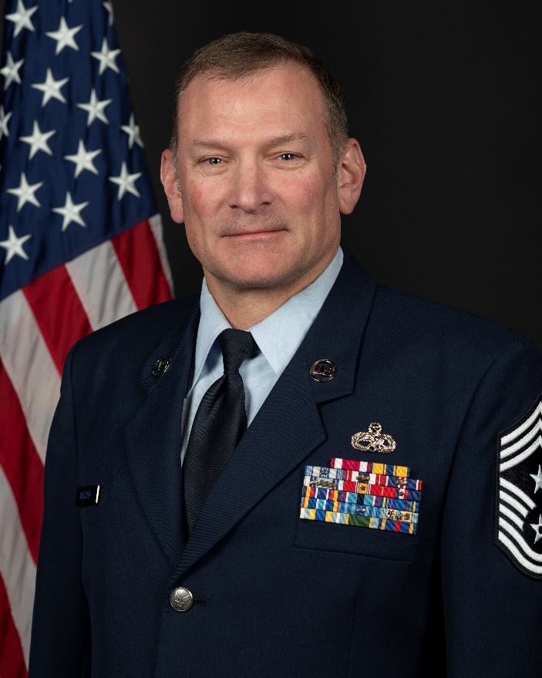Chief Master Sergeant Steven D. Webster is the Command Chief Master Sergeant of the 141st Air Refueling Wing, Washington Air National Guard, Fairchild Air Force Base, Wash. As the Command Chief, he serves as the senior enlisted advisor to the wing commander on all issues regarding the welfare, readiness, morale, and proper utilization of more than 900 enlisted force members. He coordinates with the Chief’s Council to improve and inform the enlisted force, is the functional manager for subordinate units’ first sergeants and advocates enlisted issues through the State Command Chief Master Sergeant.

Chief Webster joined the Washington Air National guard in April 1988. He attended basic training at Lackland Air Force Base. Chief Webster attended KC-135 Aircraft Maintenance technical training at Sheppard Air Force Base Texas in 1989. He spent 29 years in the 141st Aircraft Maintenance Squadron before being selected as the Senior Enlisted Leader for the 141st Maintenance Squadron. He moved back into the Senior Enlisted position at the Aircraft Maintenance Squadron in November of 2021. Chief Webster has deployed in support of operations ALLIED FORCE, KOSOVO, IRAQI FREEDOM, ENDURING FREEDOM, NOBLE EAGLE and the Global War on Terror. He was selected to be the 141st Air Refueling Wing Command Chief in November 2023. Prior to his current assignment Chief Webster was the Senior Enlisted Leader for the 141st Aircraft Maintenance Squadron, Fairchild Air Force Base, Wash.

**EDUCATION**

1988 Basic Military Training Lackland Air Force Base, Texas

1989 KC-135 Aircraft Maintenance Tactical Phase I Sheppard AFB, Texas

1990 Associate of Arts Studies, Bellevue Community College, Wash.

1991 Noncommissioned Officer Preparatory Course, Maxwell AFB, Ala.

1996 Bachelor of Arts and Science in Finance, Eastern Washington University, Wash.

2008 Noncommissioned Officer Academy, Maxwell AFB, Ala.

2012 Maintenance Supervision and Production Course, McGuire AFB, N.J.

2012 Senior Noncommissioned Officer Academy, Maxwell AFB, Ala.

2016 Associates Degree in Aviation Maintenance Technology, Community College of the Air Force, Maxwell, Ala.

**ASSIGNMENTS**

1. September 1988-November 1988, Trainee, Basic Military Training Squadron, Lackland AFB, Texas

2. November 1988-March 1989, Student, Student Training Squadron, Sheppard AFB, Texas

3. March 1989-May 1989, Student, Student Training Squadron, Fairchild AFB, Wash.

4. May 1989- July 2018, Superintendent, 141st Aircraft Maintenance Squadron, blue Aircraft Maintenance Unit Fairchild AFB, Wash.

(Deployed May 1999-June 1999, Crew Chief 171st Expeditionary Operations Group, Allied Force Kosovo, Budapest,

Hungary)

(Deployed April 2007- May 2007, Crew Chief, Manas Air Base, Tanker Task Force)

(Deployed May 2009-June 2010, Title 10 Alert Supervisor, Fairchild AFB, Wash.)

(Deployed August 2009-October 2009, Crew Chief, 340th Expeditionary Air Refueling Squadron, Operation Enduring

Freedom, Al Udeid AB, Qatar)

(Deployed November 2010-November 2010, Title 10 Alert Supervisor, Fairchild AFB, Wash.)

(Deployed December 2011-February 2012, Production Superintendent, 506th Expeditionary Air Refueling Squadron, Andersen AFB,Guam)

**ASSIGNMENTS** (Cont.)

(Deployed June 2012-September 2012, Title 10 Alert Supervisor, Fairchild AFB, Wash.)

(Deployed February 2013-April 2013, Production Superintendent, 506th Expeditionary Maintenance Squadron, Andersen AFB, Guam)

(Deployed April 2013-September 2014, Title 10 Alert Supervisor, Fairchild AFB, Wash.)

(Deployed January 2015-April 2015, Lead Production Superintendent, 340th Expeditionary Air Refueling Squadron, Operation Enduring Freedom, Al Udeid AB, Qatar)

5. August 2018- October 2021, Senior Enlisted Leader,141st Maintenance Squadron, Fairchild AFB, Wash.

(Deployed May 2019- June 2019, Liason, Korat Air Base Royal Kingdom of Thailand

(Deployed December 2021-March 2022, Senior Enlisted Leader, 340th Expeditionary Air Refueling Squadron, Aircraft Maintenance Unit Operation Enduring Freedom, Al Udeid AB, Qatar)

6. November 2021- November 2023, Senior Enlisted Leader, Aircraft Maintenance Squadron, Fairchild AFB, Wash.

7. November 2023- Present, Command Chief Master Sergeant, 141st Air Refueling Wing, Fairchild Air Force Base, Wash.

(Deployed May 2023-June 2023, Senior Enlisted Leader, 506th Expeditionary Maintenance Squadron, Andersen AFB, Guam)

**MAJOR AWARDS AND DECORATIONS**

Air Force Meritorious Service Medal

Air Force Commendation Medal

Air Force Achievement Medal with one device

Air Reserve Forces Meritorious Service Medal with eight devices

National Defense Service Medal with one device

Kosovo Campaign Medal with one device

Global War on Terror Service Medal

Humanitarian Service Medal

Nuclear Deterrence Operations Service Medal

Armed Forces Reserve Medal with three ‘M’ Devices

**OTHER ACHIEVEMENTS**

1989 Honor Graduate, Aircraft Maintenance Technical School, Sheppard AFB, Texas

1991 Maintenance Group Semi- Annual Airman of the Year, 141 Maintenance Group, Fairchild AFB, Wash.

2004 Inspector General 801X Superior Performer Award, 141 Aircraft Maintenance Squadron, Fairchild AFB, Wash.

2015 Superior Performer Award, Operation Enduring Freedom, Al Udeid Air Base, Qatar

2016 Maintenance Group Semi-Annual SNCO of the Year, 141 Maintenance Group, Fairchild AFB, Wash.

2016 141st Air Refueling Wing Senior Enlisted Member of the Year, 141 ARW, Fairchild AFB, Wash.

# EFFECTIVE DATES OF PROMOTION

Airman Basic 13 April 1988

Airman 14 April 1989

Airman First Class 15 October 1989

Senior Airman 15 April 1990

Staff Sergeant 3 June 1992

Technical Sergeant 1 December 2000

Master Sergeant 13 December 2010

Senior Master Sergeant 17 June 2013

–––

(Current as of June 2024)