|  |  |  |  |
| --- | --- | --- | --- |
| |  |  |  | | --- | --- | --- | | Seal | Biography | Flag | |
| ***U N I T E D   S T A T E S   A I R   F O R C E*** |

**CHIEF MASTER SERGEANT EDWARD G. POHL**

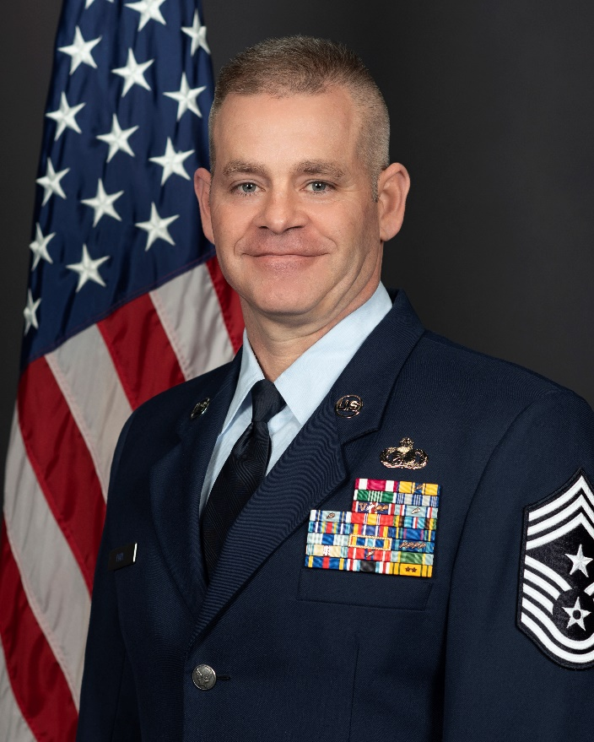Chief Master Sergeant Edward G. Pohl is the Command Chief Master Sergeant of the 141st Air Refueling Wing, Washington Air National Guard, Fairchild Air Force Base, Wash. As the Command Chief, he serves as the senior enlisted advisor to the wing commander on all issues regarding the welfare, readiness, morale, and proper utilization of more than 900 enlisted force members. He coordinates with the Chief’s Council to improve and inform the enlisted force, is the functional manager for subordinate units’ first sergeants and advocates enlisted issues through the State Command Chief Master Sergeant.

In March of 2001, Chief Pohl enlisted in the United States Air Force. Following Basic Training at Lackland Air Force Base, Texas in May of 2001, he received training as an Aircrew Egress Technician at Sheppard Air Force Base, Texas. His first duty assignment was with the 18th Component Maintenance Squadron, Kadena Air Base, Okinawa Japan serving as an Aircrew Egress craftsman on the F-15 C/D aircraft. In 2002, he deployed to Saudi Arabia in support of OPERATION SOUTHERN WATCH. In 2007, he retrained into the Fire Protection career field and was assigned to the 92nd Civil Engineer Squadron, Fairchild Air Force Base, Washington. In 2009, he deployed to Qatar in support of OPERATION ENDURING FREEDOM. In 2011, Chief Pohl transitioned to the Washington Air National Guard serving as a Financial Management Technician. Prior to his current position, Chief Pohl was the Senior Enlisted Leader of the 141st Medical Group, Fairchild Air Base Washington.

**EDUCATION**

2005 Airman Leadership School, Kadena Air Base, Okinawa Japan

2010 Non-Commissioned Officer Academy, Peterson AFB, Colo.

2010 Associate Degree in Aircraft Maintenance Technology, Community College of the Air Force, Maxwell, Ala.

2010 Associate Degree in Fire Science, Community College of the Air Force, Maxwell, Ala.

2013 Associate Degree in Public Administration Budget and Finance, Community College of the Air Force, Maxwell Ala.

2013 Senior Non-Commissioned Officer Academy by correspondence

2015 Baccalaureate Degree in Business Administration, Columbia Southern University (Summa Cum Laude)

2015 Joint Senior Enlisted Professional Military Education Course by correspondence

2015 Professional Manager Certification, Air University by correspondence

2016 Joint Senior Enlisted Professional Military Education Course II by correspondence

2019 Chief Master Sergeant Orientation Course, Joint Base Andrews, Maryland

2022 Chiefs Leadership Course, Maxwell AFB, Alabama

**ASSIGNMENTS**

Jul 2001 – Jul 2007, Aircrew Egress Systems Craftsman, 18th Component Maintenance Squadron, Kadena Air Base, Okinawa, Japan

Jul 2007 – Jul 2011, Fire Protection Craftsman, 92nd Civil Engineer Squadron, Fairchild AFB, Wash.

Jul 2011 – May 2014, Financial Management Technician, 141st Comptroller Flight, Fairchild AFB, Wash.

May 2014 – Apr 2019, Senior Enlisted Leader, 141st Comptroller Flight, Fairchild AFB, Wash.

Apr 2019 – Jan 2022, Senior Enlisted Advisor, 10th Homeland Response Force, Fairchild AFB, Wash.

Apr 2019 – Jan 2022, Senior Enlisted Leader, 141st Medical Group, Fairchild AFB, Wash.

Jan 2022 – Present, Command Chief Master Sergeant, 141st Air Refueling Wing, Fairchild Air Force Base, Wash.

**MAJOR AWARDS AND DECORATIONS**

Meritorious Service Medal

Air Force Commendation Medal with one oak leaf cluster

Army Commendation Medal

Air Force Achievement Medal

Air Force Outstanding Unit Award with V and seven devices

Air Reserves Forces Meritorious Service Medal with one device

National Defense Service Medal

Global War on Terrorism Expeditionary Medal

Global War on Terrorism Service Medal

Nuclear Deterrence Operations Service Medal

Air Force Overseas Ribbon - Long Tour with one device

Armed Forces Reserve Medal with Hourglass device

**STATE AWARDS AND DECORATIONS**

Washington Achievement Medal

Washington Emergency Service Ribbon with two devices

# EFFECTIVE DATES OF PROMOTION

Airman Basic 13 Mar 2001

Airman First Class 27 Apr 2001

Senior Airman 27 Feb 2003

Staff Sergeant 1 Mar 2005

Technical Sergeant 1 Jul 2008

Master Sergeant 15 Nov 2011

Senior Master Sergeant 28 Aug 2014

Chief Master Sergeant 1 Apr 2019

(Current as of January 2023)