U N I T E D S T A T E S A I R F O R C E

CHIEF MASTER SERGEANT BRANDON W. IVES

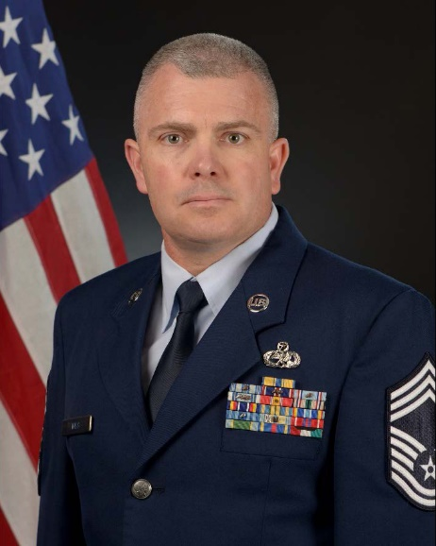
Chief Master Sergeant Brandon W. Ives is the Command Chief Master Sergeant of the 141st Air Refueling Wing, Washington Air National Guard, Fairchild Air Force Base, Wash. As the Command Chief, he serves as the senior enlisted advisor to the wing commander on all issues regarding the welfare, readiness, morale, and proper utilization of more than 900 enlisted force members. He coordinates with the Chief’s Council to improve and inform the enlisted force, is the functional manager for subordinate units’ first sergeants and advocates enlisted issues through the State Command Chief Master Sergeant.

In September of 1987, Chief Ives enlisted in the United States Air Force. He received training as an airlift aircraft maintenance technician at Sheppard Air Force Base, Texas. He was then stationed at McGuire AFB, N.J. serving as a Lockheed C-141B Starlifter crew chief. That role included support of Drug Enforcement Agency and National Security Administration missions throughout the world. In December 1989, he deployed to Lawson Army Airfield, Ga. preparing numerous C-141s and C-130s for Operation JUST CAUSE. In 1991, he was deployed to Saudi Arabia in support of Operation DESERT STORM. While there, he contributed to the relief efforts for the Kurds of Northern Iraq, via Operation PROVIDE COMFORT. In July of 1991, he joined the Connecticut Air National Guard at Bradley Air National Guard Base, East Granby, Conn. Chief Ives was assigned to the 103rd Tactical Fighter Group propulsion shop as a TF-34 engine mechanic on the A-10. In May of 1995, returning to his roots as a crew chief, he transferred to Westover Air Reserve Base, Mass., serving as a C-5 aircraft maintenance technician. Following the attacks of September 11th, 2001, he was activated and deployed to Moron Air Base, Spain, in support of Operation ENDURING FREEDOM. In 2003, he was activated in support of Operation IRAQI FREEDOM. Chief Ives voluntarily remained on active duty almost continuously until March 2008. In 2010 he was activated in support of the surge in CENTCOM’s Area of Responsibility, and deployed to Spangdahlem Air Base, Germany. In 2012, Chief Ives again volunteered to return to active duty as flightline production superintendent. His efforts helped the squadron generate 35 percent of the Air Force’s total C-5 airlift operations and delivery of over 34 million pounds of cargo to the war fighter. Prior to his current position, the Chief was the aircraft maintenance superintendent for the 103d Aircraft Maintenance Squadron, Bradley Air National Guard Base, East Granby, Conn.

EDUCATION
1991 Noncommissioned Officer Preparatory Military Course, McGuire Air Force Base, N.J.
2004 Air Force Reserve Command Noncommissioned Officer Leadership Development Course, Westover Air Reserve Base, Mass.
2004 Noncommissioned Officer Academy, Maxwell Air Force Base, Ala., by correspondence.
2010 Air Force Reserve Command Senior Noncommissioned Leadership Development Course, Westover Air Reserve Base, Mass.
2013 Associate of Applied Science Degree, Aircraft Maintenance Technology, Community College of the Air Force
2013 Senior Noncommissioned Officer Academy, Maxwell AFB, Ala., by correspondence
2013 Mobility Air Forces Production Superintendent Course, Westover Air Reserve Base, Mass.
2016 Defense Contract Management Agency, Defense Acquisition Workforce Improvement Act, Production, Quality, & Manufacturing Level II Certification, Defense Acquisition University
2016 Dynamics of International Terrorism, Hurlburt Field, Fort Walton Beach, Fla.
2017 Air National Guard Chief Executive Course, National Guard Bureau, Andrews Air Force Base, Md.
2018 Air Force Chief Leadership Course, Maxwell Air Force Base, Ala
2018 Dynamics of International Terrorism and Antiterrorism Officer Course Level II + III, Hurlburt Field, Fort Walton Beach, Fla.

ASSIGNMENTS
September 1987 – October 1987, Student, Basic Military Training, Lackland Air Force Base, Texas
October 1987 – December 1987, Student, Technical Training School, Sheppard Air Force Base, Texas

ASSIGNMENTS (Cont.)
December 1987 – July 1991, C-141 Crew Chief, 439th Organizational Maintenance Squadron, McGuire Air Force Base, N.J.
August 1991 – May 1995, Jet Engine Mechanic, 103rd Tactical Fighter Group, Bradley Air National Guard Base, Conn.
May 1995 – April 2016, C-5 Crew Chief, 439th Aircraft Maintenance Squadron, Westover Air Reserve Base, Chicopee, Mass.
April 2016 – April 2019, Superintendent, 103rd Aircraft Maintenance Squadron, Bradley Air National Guard Base, Conn.

MAJOR AWARDS AND DECORATIONS
Air Force Commendation Medal
Air Force Achievement Medal with one oak leaf cluster

PROFESSIONAL MEMBERSHIPS AND ASSOCIATIONS
Enlisted Association of the National Guard
Air Force Sergeants’ Association

EFFECTIVE DATES OF PROMOTION
Airman Basic, Sept. 17, 1987
Airman March 17, 1988
Airman First Class, Jan. 17, 1989
Senior Airman Sept. 17, 1990
Staff Sergeant May 1, 1995
Technical Sergeant July 1, 2002
Master Sergeant March 1, 2012
Senior Master Sergeant March 1, 2014
Chief Master Sergeant Nov. 6, 2016

(Current as of April 2019)

